2D Mesh generation guide

Perumal Nithiarasu
www.zetacomp.com

e-mail any mistakes to: info@zetacomp.com

1. Introduction

The source code for mesh generation uses the Delaunay triangulation to create unstructured 2D meshes in both simply and multiply connected domains. For further details on the theory behind the method, refer to

Kumar KSV, Babu AVR, Seetharamu KN, Sundararajan T and Narayana PAA, A generalized Delaunay triangulation algorithm with adaptive grid size control, Communications in Numerical Methods in Engineering, 13 (12): 941-948 DEC 1997

Those who want to understand the code, refer to the comments provided in side the subroutines. It needs only one input file ‘inputs’ to define the geometry.

2. Simply connected domains

2.1 Domain with straight lines

Let us consider a simply connected domain as shown in Figure 1. The geometry is a square domain of size 1. The input file (inputs) for the mesh generator is

4
0.0, 0.0, 1.0, 0.0, 40, 1, 0.5, 0.0, 180.0, 0
1.0, 0.0, 1.0, 1.0, 40, 1, 1.0, 0.5, 180.0, 0
1.0, 1.0, 0.0, 1.0, 40, 1, 0.5, 1.0, 180.0, 0
0.0, 1.0, 0.0, 0.0, 40, 1, 0.0, 0.5, 180.0, 0

The first line in the above input file represents the number of boundary segments in the simply connected domain. Following lines define each segments and meshing requirements. The parameters are
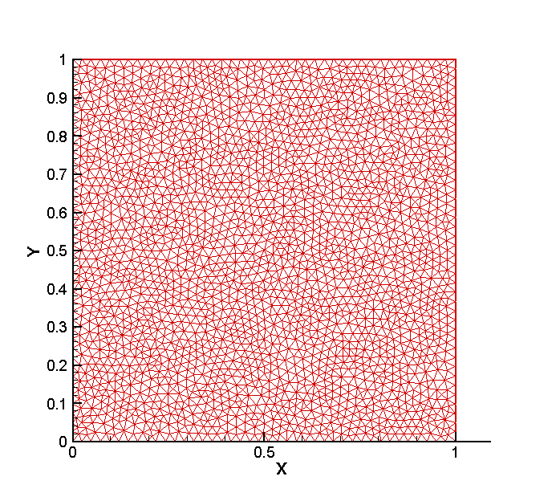
Figure 1 Mesh of a simply connected domain.

x-coordinate of the first point, y – coordinate of the first point, x-coordinate of the second point, y-coordinate of the second point connecting the segment, approximate number of mesh points, code for straight line (1) or curve (2), center of the segment (curves only), angle covered by the curve (curves only), multiply counted points (multiply connected domains only).

2.2 Domain with curves

The input file (inputs) for the domain shown in Figure 2 is

5
-2.0, 0.0, -1.0, 0.0, 10, 1, 0.0, 0.0, 180.0, 0
-1.0, 0.0, 0.0, 1.0, 10, 2, 0.0, 0.0, -90.0, 0
0.0, 1.0, 0.0, 3.0, 10, 1, 0.0, 0.0, 180.0, 0
0.0, 3.0,-2.0, 3.0, 10, 1, 0.0, 0.0, 180.0, 0
-2.0, 3.0,-2.0, 0.0, 10, 1, 0.0, 0.0, 180.0, 0

The main difference between the previous and present input file is the latter includes a curved boundary (second segment), which covers an angle of 90 degrees in the clockwise (negative) direction. Appropriate changes in the third line should be noted.
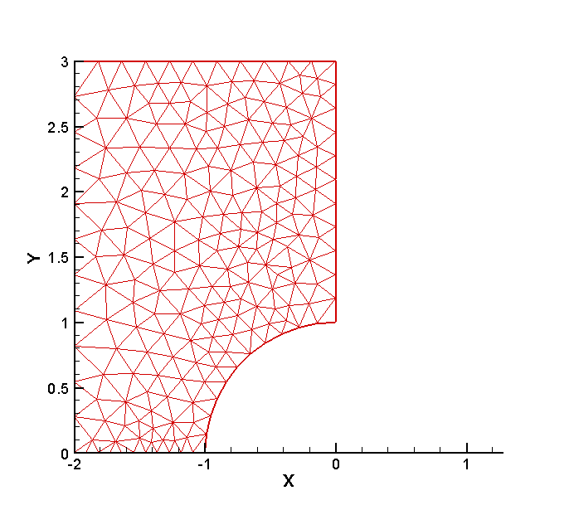
Figure 2 A simply connected domain with a curved boundary

3. Multiply connected domains

3.1 Domain with straight lines

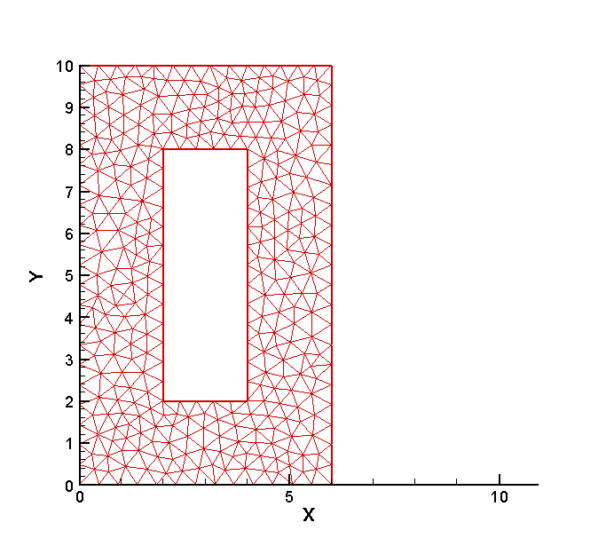
Figure 3 A simple multiply connected domain

The input file for the multiply connected domain shown in Figure 3 is

11
0.0, 0.0, 6.0, 0.0, 12, 1, 0.0, 0.0, 0.0, 0
6.0, 0.0, 6.0, 10.0, 20, 1, 0.0, 0.0, 0.0, 0
6.0, 10.0, 4.0, 10.0, 4, 1, 0.0, 0.0, 0.0, 0
4.0, 10.0, 4.0, 8.0, 0, 1, 0.0, 0.0, 0.0,0
4.0, 8.0, 4.0, 2.0, 12, 1, 0.0, 0.0, 0.0, 0
4.0, 2.0, 2.0, 2.0, 4, 1, 0.0, 0.0, 0.0, 0
2.0, 2.0, 2.0, 8.0, 12, 1,0.0, 0.0, 0.0, 0
2.0, 8.0, 4.0 ,8.0, 4, 1, 0.0, 0.0, 0.0, 0
4.0, 8.0, 4.0, 10.0, 0, 1, 0.0, 0.0, 0.0, 5
4.0,10.0, 0.0, 10.0, 8, 1, 0.0, 0.0, 0.0, 4
0.0, 10.0, 0.0, 0.0, 20, 1,0.0, 0.0, 0.0, 0

Note that the inner boundary segments are defined in the clockwise fashion. However the outer boundary segments are always defined in anti-clockwise direction. When the connection is made between the inner and outer domains, the number of nodes on the connecting segment should be zero (see lines 4 and 9) in the above input file. It is also important to indicate the repeated points (see lines 9 and 10) when coming out of the inner domain.

3.2. Domain with curves

The input file for the domain shown in Figure 4 is

9
0.00, -4.0, 16.0, -4.0, 20, 1, 0.0, 0.0, 180.0, 0
16.0, -4.0, 16.0, 0.0, 5 , 1, 0.0, 0.0, 180.0, 0
16.0, 0.0, 4.50, 0.0, 0 , 1, 0.0, 0.0, 180.0, 0
4.5, 0.0, 3.5, 0.0, 20, 2, 4.0, 0.0,-180.0, 0
3.5, 0.0, 4.5, 0.0, 20, 2, 4.0, 0.0,-180.0, 0
4.5, 0.0, 16.0, 0.0, 0, 1, 0.0, 0.0, 180.0, 4
16.0, 0.0, 16.0, 4.0, 5 , 1, 0.0, 0.0, 180.0, 3
16.0, 4.0, 0.0, 4.0, 20, 1, 0.0, 0.0, 180.0, 0
0.0, 4.0, 0.0, -4.0, 10, 1, 0.0, 0.0, 180.0, 0

Figure 4 A multiply connected domain

4. Output files

As mentioned before the only one input file is needed for the mesh generator is inputs. Two output files mesh_output.plt and mesh_output_tplot_mesh.plt, are generated by the mesh generator. The first file is the mesh file used in the CBSFlow (2d) solvers. The second contains a TECPLOT formatted file for visualisation of the mesh. The mesh format for the CBSFlow (2d) solvers is provided in their accompanying documentation.

